 | Write the Formula | Draw the Structure | Name the Shape | Determine Polarity  Polar/Nonpolar
Hydrogen | H₂
Water
Methane
(Carbon Tetrahydride)
Oxygen
Ammonia
(Nitrogen Trihydride)
Dichloromethane | CH₂Cl₂
Nitrogen
Methanol | CH₃OH
Carbon Tetrachloride

Carbon Dioxide
Hydrogen Fluoride

Hydrogen Sulfide
Ethyne | C₂H₂
Molecular Shapes
x= Occupied
E= Empty
Total Bonds | 0 lone pair | 1 lone pair | 2 lone pairs
2 | Linear
3 | 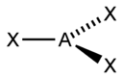  Trigonal planar | 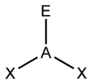  Bent
4 | 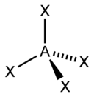  Tetrahedral | 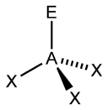  Trigonal pyramid | 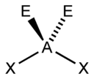  Bent

